**DAILY ONLINE ACTIVITIES SUMMARY**

|  |  |  |  |  |  |  |  |  |
| --- | --- | --- | --- | --- | --- | --- | --- | --- |
| **Date:** | **14/07/2020** | | | | | **Name:** | **Shailashree** | |
| **Sem & Sec** | **IV sem & B section** | | | | | **USN:** | **4AL18CS077** | |
| **Online Test Summary** | | | | | | | | |
| **Subject** | | **-** | | | | | | |
| **Max. Marks** | | **30** | | **Score** | | | **-** | |
| **Certification Course Summary** | | | | | | | | |
| **Course** | **Predictive modeling and analysis** | | | | | | | |
| **Certificate Provider** | | | **Greatlearning academy** | | **Duration** | | | **2.5hours** |
| **Coding Challenges** | | | | | | | | |
| **Problem Statement1:** Given an expression string exp. Examine whether the pairs and the orders of “{“,”}”,”(“,”)”,”[“,”]” are correct in exp. For example, the program should print 'balanced' for exp = “[()]{}{()()}” and 'not balanced' for exp = “[(])” | | | | | | | | |
| **Status: Executed** | | | | | | | | |
| **Uploaded the report in Github** | | | | | **YES** | | | |
| **If yes Repository name** | | | | | **Online coding** | | | |
| **Uploaded the report in slack** | | | | | **YES** | | | |

Online Test Summary: No internals conducted today.

Online Certification Course Summary: Today I started new course that Predictive modeling and analysis in Great Learning. In today’s session I have learnt about Predictive Modeling-classification Techniques.

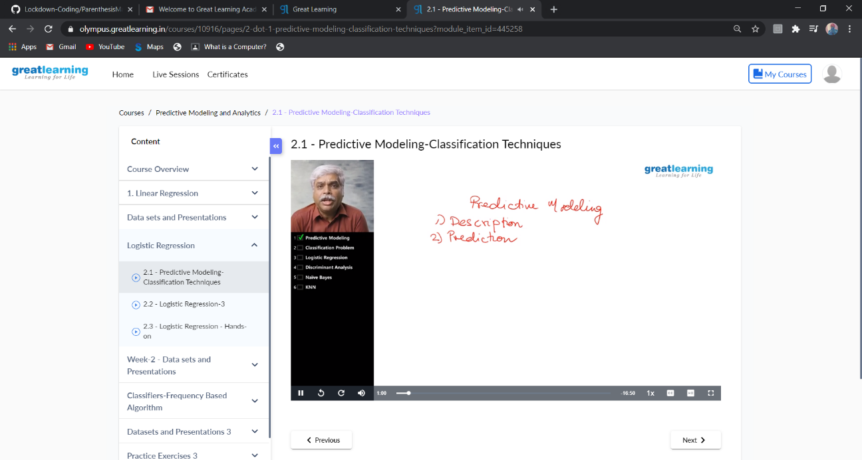

These are the snap shots of today’s sessions.

Online Coding Summary: **Today I had received one program from prof. Shilpa CSE Dept. The program is mentioned above in the coding challenges(pg.01). I have also uploaded it to my GitHub repository.**

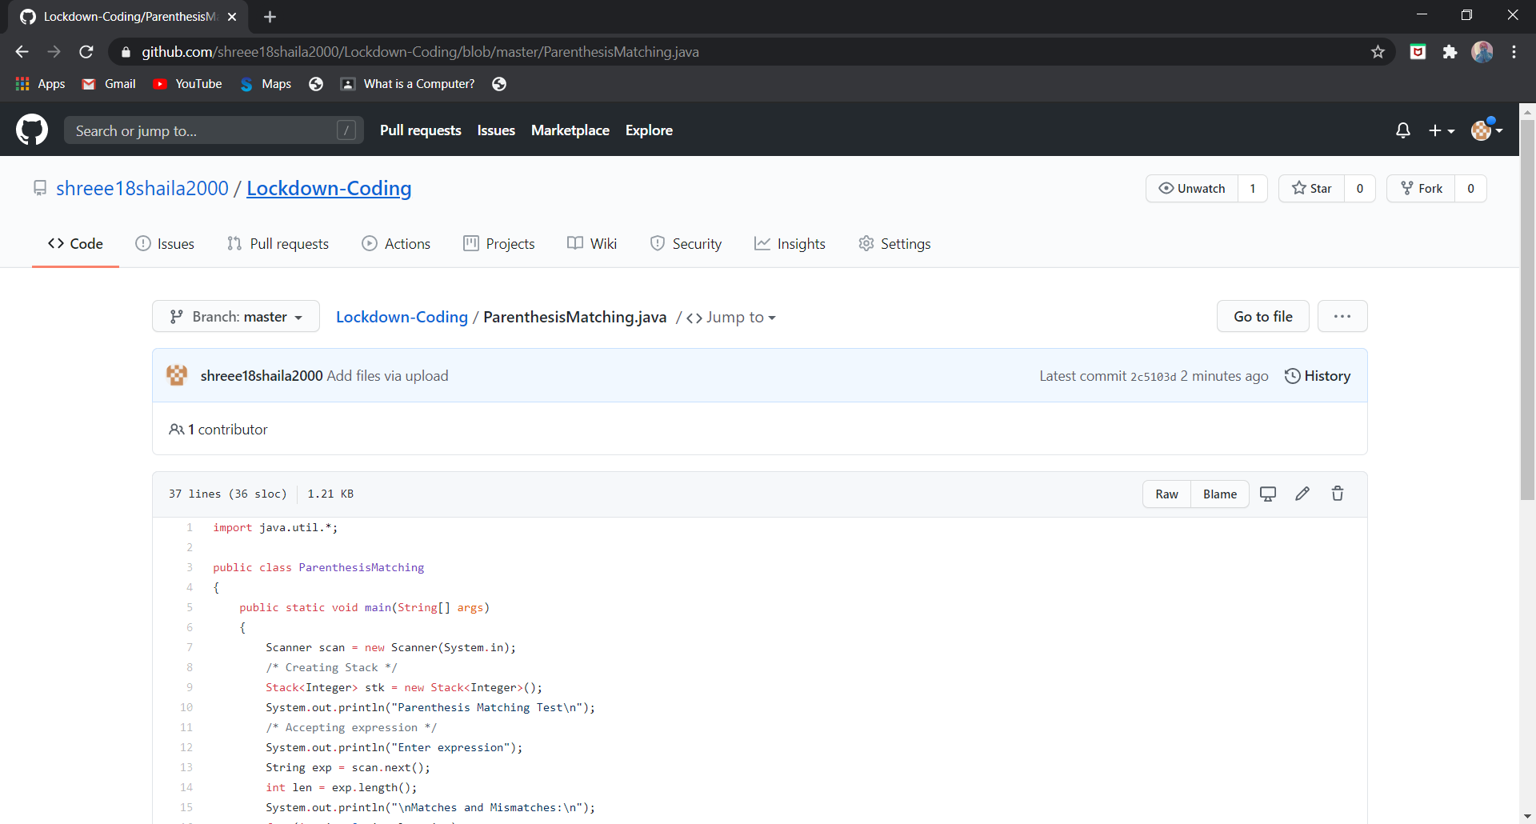

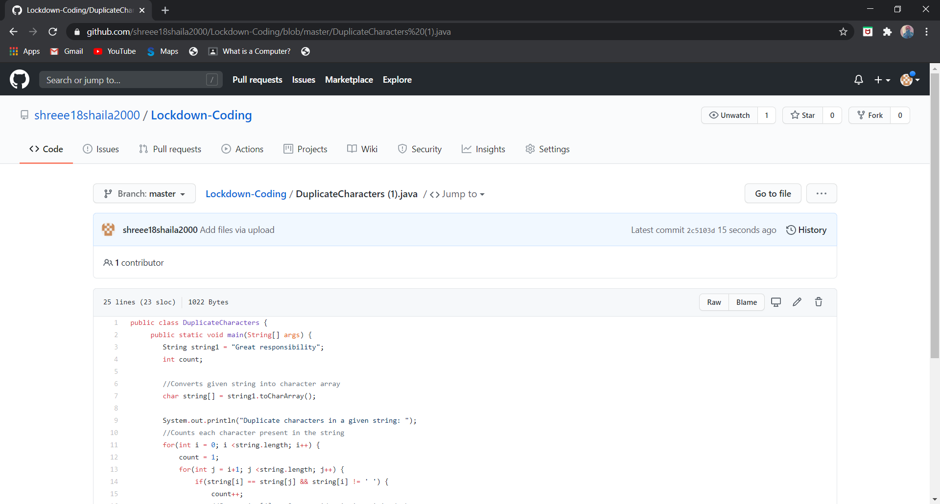

**This is the snap shot of my GitHub repository** where I have uploaded the code. File name is are ParenthesisMatching.java, Duplicate Characters (1).java

Online Training: No training classes are conducted.